IT24510014

PS Lab 06 - Exercise

01)

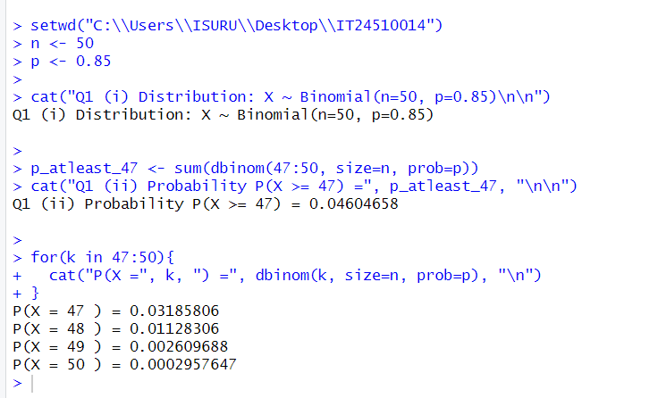

02)

